1. The process of finding the largest value (i.e., the maximum of a group of values) is used frequently in computer applications. For example, a program that determines the winner of a sales contest would input the number of units sold by each salesperson. The salesperson who sells the most units wins the contest. Build a java application that inputs a series of 10 integers and determines and prints the largest integer. Your program should use at least thefollowing three variables:a. counter: A counter to count to 10 (i.e. to keep track of how many numbers have been input and to determine when all 10 numbers have been processed.b. number: The inter most recently input by the user.c. largest: The largest number found so far.Note: Every time the sales figure of one employee is entered, the application should ask the user if they want to enter any more sales figures of a salesperson!

ANSWER

import java.util.ArrayList;

import java.util.Arrays;

import java.util.Scanner;

public class SaleOfEmployee {

static int counter = 0, number, largest;

static int findLargest(Object[] ar) {

if ((int) ar.length == 1)

return (int) ar[0];

else {

largest = (int) ar[0];

for (int i = 0; i < ar.length; i++) {

if ((int) ar[i] > largest)

largest = (int) ar[i];

}

}

return largest;

}

public static void main(String[] args) {

System.out.println("My Name is Risav Mondal Roll No:- 50");

ArrayList<Integer> al = new ArrayList<>();

Scanner scan = new Scanner(System.in);

while (counter < 10) {

System.out.print("Enter The Sale of " + (++counter) + "th Sales Person:\t");

number = scan.nextInt();

al.add(number);

largest = findLargest(al.toArray());

System.out.println("Largest Sale is:\t" + largest);

System.out.print("Do You enter any other sale (Press 1):\t");

if (scan.nextInt() != 1)

break;

}

System.out.println("Exiting System ...");

}

}

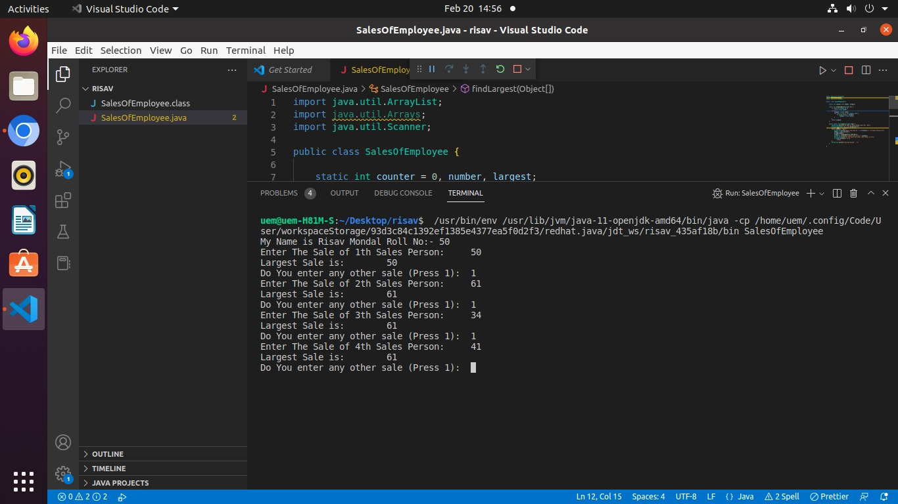

2. Write an application that prompts the user to enter the size of the side of a square, then displays a hollow square of that size made of asterisks. Your program should work for squares of all side lengths between 1 and 20.

**ANSWER**

public class SquarePattern {

static void printStar(int n) {

for (int i = 0; i < n; i++) {

System.out.print("* ");

}

System.out.println();

}

static void printStarWithSpace(int n) {

System.out.print("*");

for (int i = 0; i < (2 * n - 3); i++) {

System.out.print(" ");

}

System.out.println("*");

}

public static void main(String[] args) {

System.out.println("MY Name is Risav Mondal Roll No is 50");

int n = 10;

printStar(n);

for (int i = 0; i < n - 2; i++) {

printStarWithSpace(n);

}

printStar(n);

}

}

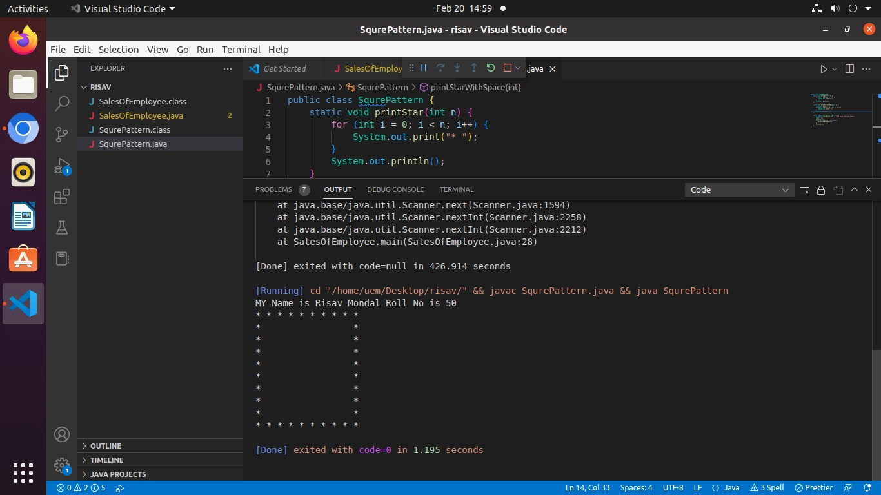

3. Write a program to compute the following formula.e= 1/0!+ 1/1! +½! + ⅓!+................+ 1/n!

**ANSWER**

public class Formula {

static double factorial(int n) {

double fact = 1;

for (int i = 1; i <= n; i++) {

fact *= i;

}

return fact;

}

static double compute(int n) {

double result = 0;

for (int i = 0; i <= n; i++) {

result += 1 / factorial(i);

}

return result;

}

public static void main(String[] args) {

System.out.println("MY Name is Risav Mondal Roll No 50");

int n = 1;

System.out.println("The Value of Formula is:\t" + compute(n));

}

}

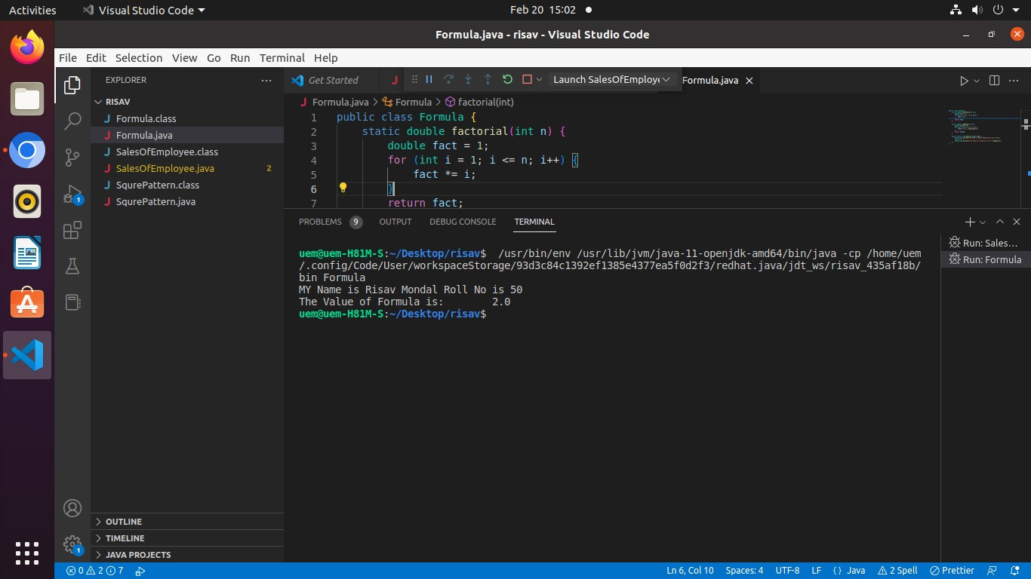

4. Using an enhanced for (for-each) loop, copy the content of one 3-dimensional array to another 3-dimensional array and display its contents.

**ANSWER**

public class Array3D {

public static void main(String[] args) {

System.out.println("MY Name is Risav Mondal Roll No is 50");

int[][][] array = {

{

{ 1, 2 }, { 3, 4 }

},

{

{ 5, 6 }, { 7, 8 }

},

};

// using for each loop ...

for (int[][] a : array) {

for (int[] b : a) {

for (int c : b) {

System.out.print(c + "\t");

}

System.out.println();

}

System.out.println();

}

// using normal for loop ...

for (int i = 0; i < 2; i++) {

for (int j = 0; j < 2; j++) {

for (int k = 0; k < 2; k++) {

System.out.println("intArray [" + i + "][" + j + "][" + k + "] = " + array[i][j][k]);

}

System.out.println();

}

System.out.println();

}

}

}

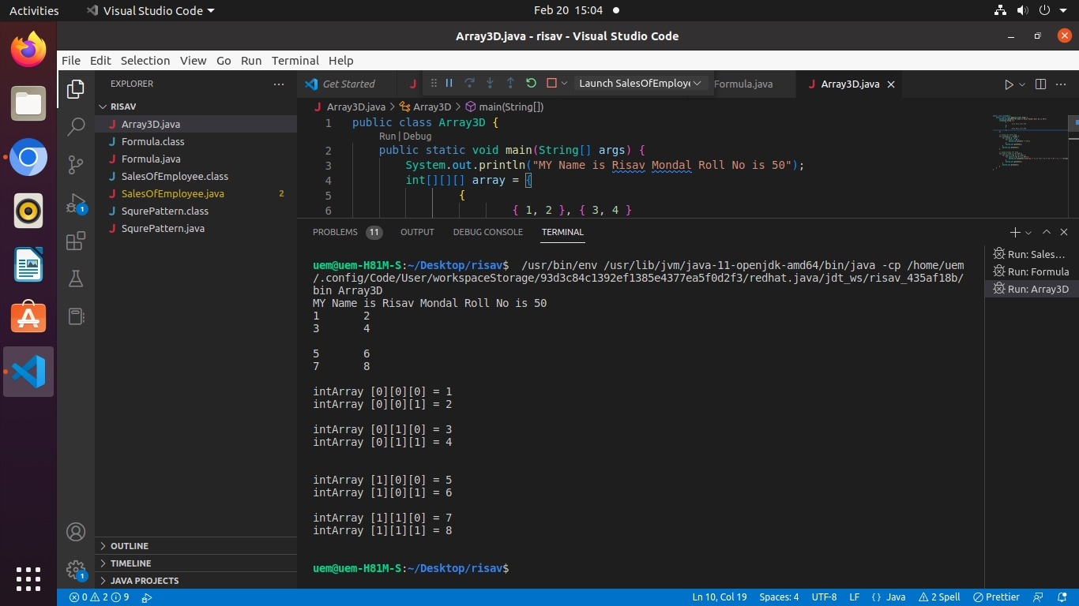

5. Create the following vase pattern using a loop:************\ /

/ \

\ /

/ \

\ /

/ \************

**ANSWER**

public class Pattern {

static void printStar(int len) {

System.out.println("MY Name is Risav Mondal Roll No is 50");

for (int i = 0; i < len; i++) {

System.out.print("*");

}

System.out.println();

}

static void printFrontCover(int len) {

System.out.print("\\");

for (int i = 0; i < len - 2; i++) {

System.out.print(" ");

}

System.out.println("/\n");

}

static void printBackCover(int len) {

System.out.print("/");

for (int i = 0; i < len - 2; i++) {

System.out.print(" ");

}

System.out.println("\\\n");

}

public static void main(String[] args) {

int height = 7;

int length = 12;

printStar(length);

for (int i = 0; i < height - 2; i++) {

printFrontCover(length);

printBackCover(length);

}

printStar(length);

}

}

